Given the following graph: 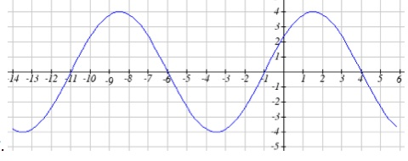
a) Find the amplitude b) Find the period

c) The equation of the graph can be written in the form y = Asin(Bx+C), find A,B,and C.

